Design Defects and Restructuring SE-4031


RESEARCH PAPER
Behavioural Synchronization Design Pattern

SUBMITTED TO:
Mr. Abdul Rahman
Mr. Muhammad Tahir Asif

SUBMITTED ON:
6th May 2024 at 11 AM

GROUP MEMBERS:
INSHA SAMNANI 20K-0247
ISMAIL AHMED ANSARI 20K-0228
ANJIYA MUHAMMAD ALI 20K-1687



Table of Contents
I. INTRODUCTION 1
Research Questions 2
Research Objectives 2
Research Hypothesis 2
II. TABULAR LITERATURE REVIEW 3
III. RESEARCH GAP 5
Comparison of Existing Solutions with Behavioural Synchronization Pattern: 6
IV. METHODOLOGY 8
V. ARCHITECTURE DIAGRAM 8
VI. CLASS DIAGRAM 8
VII. CORE SOLUTION 8
VIII. SAMPLE CODE 9
IX. CASE STUDIES 9
Case Study 1: Social Media Content Moderation System 9
Case Study 2: E-commerce Inventory Management System 10
Case Study 3: Real-time Collaborative Document Editing Platform 10
Case Study 4: Distributed Messaging System 10
X. RESULTS 10
XI. GRAPHICAL ANALYSIS 11
XII. CONCLUSION 11
XIII. RECOMMENDATIONS 12
References 13

Behavioural Synchronization Design Pattern
Insha Samnani, Anjiya Muhammad Ali, and Ismail Ahmed Ansari
Abstract In the dynamic landscape of modern software systems, achieving consistent and synchronized behavior across diverse services stands as a pivotal challenge. This research paper delves into the deficiencies of conventional object synchronization methodologies and Observer design patterns within concurrent systems, shedding light on their adverse effects on code structure, modularity, and scalability. Through a thorough exploration of prevalent synchronization mechanisms and patterns like semaphores, monitors, and aspect-oriented programming, this study pinpoints their limitations and proposes innovative remedies to overcome these obstacles. Specifically, it introduces the Object Synchronizer pattern, scrutinizing its capability to disentangle synchronization from functionality, bolster modularity, and foster code reusability. Furthermore, the paper delves into the potential of aspect-oriented programming in refining synchronization strategies, with the aim of optimizing system scalability, responsiveness, and adaptability in multi-threaded environments.
The research endeavors to provide actionable insights into improving synchronization efficiency, scalability, and modularity in multi-threaded environments. Through empirical studies, the paper explores various synchronization mechanisms and design patterns, evaluating their effectiveness and applicability in contemporary software development contexts. By dissecting existing prototypes and implementations, the study aims to bridge the gap between theoretical understanding and practical implementation, offering developers a comprehensive understanding of efficient synchronization techniques tailored for concurrent applications. Furthermore, the paper proposes the Behavioral Synchronization Pattern as a promising alternative, highlighting its potential to address data synchronization concerns while preserving modularity and scalability in modern software systems.
Through rigorous experimental assessments and meticulous comparisons with established methodologies, this research paper contributes significantly to advancing the comprehension and implementation of efficient synchronization techniques tailored for concurrent applications. By combining theoretical analysis with practical examination, the study offers developers valuable insights and practical solutions for designing resilient and adaptable concurrent systems in the contemporary software landscape.
Index Terms— Asynchronous Method Invocation, Behavioral Synchronization pattern, Concurrency Patterns, Thread Safety

INTRODUCTION
Problem Statement: In contemporary software development, the demand for robust and scalable concurrent systems is ubiquitous. However, traditional approaches to object synchronization, exemplified by mechanisms such as semaphores and monitors, and reliance on design patterns like the Observer pattern, often fall short in meeting the evolving requirements of modern applications.
One significant challenge arises from the inherent complexity of managing synchronization within concurrent systems. The use of low-level synchronization primitives like semaphores and monitors can lead to code tangling, where synchronization logic becomes interspersed with core application logic. This tangling not only hinders code readability and maintainability but also complicates debugging and testing processes. Furthermore, such tightly coupled synchronization mechanisms hinder the scalability of concurrent systems, as they impose rigid control flow and inhibit the efficient utilization of system resources.
Moreover, encapsulating synchronization within objects, as commonly practiced in traditional Object-Oriented Programming (OOP) paradigms, introduces additional complexities. While this approach aims to localize synchronization logic within individual objects, it often leads to entangled dependencies between objects, compromising modularity and hindering code reuse. This undermines the fundamental principles of OOP, such as encapsulation and abstraction, and makes it challenging to evolve and extend concurrent systems over time.
Additionally, the conventional use of design patterns, such as the Observer pattern, exacerbates code scattering and coupling concerns in concurrent systems. The Observer pattern, while effective in facilitating communication between components, often results in tight coupling between observers and subjects, making it difficult to modify or extend the system without affecting its overall structure. This tight coupling not only impedes code maintainability but also inhibits the adoption of alternative concurrency strategies or architectural changes.
These limitations underscore the pressing need for novel synchronization strategies and concurrency patterns capable of mitigating code entanglement, promoting modular design, and enhancing system scalability and responsiveness in multi-threaded environments. Exploring innovative solutions that decouple synchronization concerns from core application logic, foster code modularization, and facilitate seamless integration of concurrent components is essential to meet the challenges posed by modern software development paradigms.

Research Questions:
- How does the traditional approach to object synchronization, relying on mechanisms such as semaphores and monitors, contribute to code tangling and hinder the scalability of concurrent applications?
- What are the drawbacks of encapsulating synchronization within objects themselves, and how does this approach impact modularity, extensibility, and code reusability in object-oriented systems?
- How does the traditional Observer design pattern contribute to code scattering and coupling between Subject and Observer objects, particularly in terms of data synchronization concerns?
- What are the limitations of existing as pectized versions of the Observer design pattern, and how can aspect-oriented programming be further leveraged to address data synchronization concerns while maintaining the intent of the original pattern?
- How can the inherent limitations of traditional concurrency control mechanisms be addressed to enhance system scalability and responsiveness in multi-threaded environments?
- What strategies can be employed to optimize the coordination and communication between concurrent processes or threads, thereby mitigating contention issues and improving overall system performance?

Research Objectives:
- Investigate the efficiency and scalability of the current synchronization mechanism in concurrent systems, focusing on its ability to handle high contention scenarios and its impact on overall system performance.
- Evaluate the maintainability and flexibility of the existing synchronization approach in terms of code modularity, extensibility, and reusability, particularly in the context of evolving system requirements and changing concurrency patterns.
- How does the traditional Observer design pattern contribute to code scattering and coupling between Subject and Observer objects, particularly in terms of data synchronization concerns?
- What are the limitations of existing as pectized versions of the Observer design pattern, and how can aspect-oriented programming be further leveraged to address data synchronization concerns while maintaining the intent of the original pattern?
- Identify potential shortcomings in the current approach to concurrency control, particularly in scenarios with high contention, to pinpoint areas where system responsiveness may be compromised.
- Develop and implement a novel synchronization strategy based on improved design principles to enhance system scalability, responsiveness, and adaptability in multi-threaded environments.

Research Hypothesis: “Behavioral Synchronization Pattern” can effectively address data synchronization concerns while preserving the intent of the original “Object Synchronizer Pattern” [1], “Publish Subscribe Pattern” [3] and “Observer Design Pattern” [4], by providing a more flexible and modular approach, thus enhancing system scalability and responsiveness in multi-threaded environments.

TABULAR LITERATURE REVIEW
Sr. No | Investigator(s) | Material Used | Experimental Design Technique | Input Parameters Considered | Output (response) | Findings of the Study
1 | António Rito Silva, João Pereira, José Alves Marques | Previous techniques such as persistent space locking mechanisms and synchronization mechanisms like semaphores and monitors were used as reference points. | The implementation of the Object Synchronizer pattern was carried out through the design and development of various classes and interfaces, including Shape, ShapeSynchronizationInterface, SynchronizationPredicate, and Synchronizer. These classes encapsulate different aspects of object synchronization and provide the necessary functionality to control invocations and maintain consistency. | The input parameters considered in this research paper include the requirements for object synchronization in a cooperative drawing application, such as the need to control invocations to preserve consistency, the different synchronization policies needed for various shapes (private, publicly readable, publicly writable), and the forces driving the design of the Object Synchronizer pattern (extensibility, modularity, encapsulation, reusability). | Object Synchronizer Pattern [1] | The study demonstrated the implementation and benefits of the Object Synchronizer pattern in managing object synchronization in a cooperative drawing application. It highlighted the pattern's ability to decouple synchronization from functionality, support various synchronization policies, and ensure consistency in object invocations. Additionally, it emphasized the advantages of encapsulation, modularity, extensibility, and reuse facilitated by the pattern.
2 | Matthew F. Tennyson | Aspect-oriented programming (AOP) concepts and tools such as AspectJ were utilized for implementing and evaluating the proposed Publish Subscribe pattern. | The research paper employs an aspect-oriented design approach to propose and evaluate the Publish Subscribe pattern as an alternative to the traditional Observer design pattern. It involves the design and development of concrete classes and aspects to implement the pattern, utilizing both static and dynamic weaving techniques to separate synchronization concerns from concrete subject and observer classes. | Input parameters considered in the study include aspects of the software architecture (e.g., Subject and Observer classes), design patterns (Observer pattern, Publish Subscribe pattern), and AOP implementation details (e.g., pointcuts, advice). | Publish Subscribe Pattern [3] | The study demonstrates the effectiveness of the Publish Subscribe pattern in managing object synchronization in software systems. It highlights the pattern's ability to decouple synchronization concerns from concrete classes, promoting modularity, performance, scalability, flexibility, maintenance, and reusability. Additionally, the study emphasizes the advantages of encapsulation and separation of concerns facilitated by the aspect-oriented approach, contributing to cleaner and more maintainable software architectures.
3 | Kenneth A. Reek, Professor | The research paper employed traditional semaphore-based synchronization mechanisms, including binary and counting semaphores. These mechanisms served as the foundation for understanding concurrency control and managing access to critical sections of code. Additionally, classical synchronization problems such as the producer-consumer and readers-writers problems were studied to grasp fundamental concepts in concurrent programming and resource management. | To implement the "Pass the Baton" pattern described in the research paper, modifications were made to existing semaphore-based synchronization mechanisms. Processes were identified where reentries into mutual exclusion occurred, as outlined in the pattern's steps. By eliminating these reentries and ensuring that unblocked processes stayed within the mutual exclusion until completion, the Pass the Baton pattern was effectively integrated. Emphasis was placed on allowing only one process to be unblocked at a time and preventing newly arriving processes from interrupting the sequential order of execution. | In the research paper, various input parameters were taken into account to assess the Pass the Baton pattern's effectiveness and efficiency. These parameters included the number of concurrent processes or threads accessing shared resources, the frequency of resource contention, the complexity of critical sections, and the characteristics of the underlying hardware and operating system environment. Furthermore, evaluations were conducted regarding the overhead of synchronization primitives and their impact on system performance to determine the practicality of adopting the Pass the Baton pattern in real-world scenarios. | Pass the Baton pattern [5] | The study confirmed that implementing the Pass the Baton pattern effectively addressed concurrency issues by eliminating reentries into mutual exclusion. Sequential unblocking of processes improved system cohesion and adaptability to varying loads, showcasing the pattern's efficacy in enhancing concurrency control and resource management.

RESEARCH GAP
Despite the extensive use of “Object Synchronizer Pattern”, “Publish Subscribe Pattern” and “Observer Design Pattern”, significant gaps remain in their effectiveness and scalability. Firstly, while “Object Synchronizer Pattern” [1]having mechanisms such as semaphores and monitors are widely employed, their reliance often leads to code tangling and scalability issues in high contention scenarios. Secondly, “Publish Subscribe Pattern”, [3]although commonly practiced, presents challenges in modularity, extensibility, and code reusability, hindering the adaptability of concurrent systems to evolving requirements. Thirdly, the “Pass the Baton Pattern”, [5]while facilitating communication between Subject and Observer objects, tends to introduce code scattering and coupling concerns, particularly regarding data synchronization. These gaps highlight the need for alternative synchronization strategies. As a response, the proposed “Behaviour Synchronization Pattern” offers a promising alternative by decoupling synchronization from functionality, promoting modularity, and addressing data synchronization concerns more effectively. [2]Through its novel approach, it seeks to mitigate the limitations of existing patterns and provide a more adaptable and scalable solution for concurrent systems.

Comparison of Existing Solutions with Behavioural Synchronization Pattern:
Aspect | Object Synchronizer Pattern | Publish Subscribe Pattern | Pass the Baton Pattern | Behavioural Synchronization Pattern
Synchronization Mechanism | Decouples synchronization from functionality, supports various policies. [1] | Research lacks exploration into novel aspect-oriented synchronization mechanisms, specifically in isolating concerns from concrete classes. [3] | Lack efficiency in highly contended scenarios due to its sequential unblocking approach, potentially leading to increased contention and performance degradation. | Utilizes an internal thread for operation execution, simplifies synchronized access to shared resources.
Modularity | Provides encapsulation, modularity, extensibility, and reuse of synchronization policies. [1] | Insufficient investigation into modular synchronization approaches, overlooking benefits of separating logic into reusable aspects. [3] | Exhibit limited modularity as it focuses primarily on managing concurrency within a single critical section, potentially leading to difficulties in separating concerns and maintaining code clarity. | Enhances modularity by separating operation execution from invocation, simplifies maintenance.
Performance | May introduce overhead due to increased number of classes and objects. [1] | Gap in understanding performance implications of aspect-oriented synchronization, particularly in terms of runtime overhead. [3] | Suffer from performance bottlenecks, especially under heavy loads, due to its reliance on sequential unblocking and potential contention issues within the critical section. | Improves performance by simplifying synchronization and reducing overhead associated with synchronization policies.
Scalability | May face challenges in handling high contention scenarios efficiently. [1] | Limited research on scalability of aspect-oriented synchronization patterns for evolving system requirements. [3] | Face challenges in scaling effectively to accommodate increasing numbers of concurrent processes or threads, as its sequential unblocking approach may introduce scalability limitations and contention overhead. | Offers scalability by facilitating concurrent access to shared resources and efficient resource management.
Flexibility | Offers customization of synchronization policies but may not be optimal for all scenarios. [1] | Inadequate examination of flexibility in adapting aspect-oriented synchronization to diverse application needs. | Lack flexibility in adapting to changing system requirements or concurrency patterns, as its design primarily focuses on managing access to shared resources through a rigid sequential unblocking mechanism. | Provides flexibility through customizable object behaviours and policies, adaptable to varying concurrency requirements.
Maintenance | Requires careful management of synchronization code within objects, potential for complexity and errors. [1] | Lack of research on maintenance advantages of aspect-oriented synchronization patterns. | Pose maintenance challenges over time, particularly in large-scale systems, as its design may lead to complex and tightly coupled code structures, making it harder to implement changes or updates. | Simplifies maintenance with a clear separation between operation execution and synchronization, easier debugging, and troubleshooting.
Reusability | Allows for independent reuse of synchronization code and functionality but may introduce code tangling. [1] | Research gap in exploring reusability benefits of encapsulating synchronization logic in aspects. | Offer limited reusability potential across different components or systems, as its design is tailored specifically to manage concurrency within critical sections, potentially limiting its applicability in diverse contexts. | Enhances reusability through encapsulation of object behaviours, promotes code reuse without coupling synchronization to functionality.

METHODOLOGY
For this research, we conducted an empirical study focused on investigating and addressing deficiencies in existing object synchronization methodologies and Observer design patterns within concurrent systems. Our research aimed to provide insights into improving synchronization efficiency, scalability, and modularity in multi-threaded environments.
Data collection for this study primarily involved a combination of literature review, theoretical analysis, and practical examination of source code. We conducted an extensive review of three research papers to understand the current landscape of object synchronization techniques and design patterns. This literature review informed the formulation of research questions, objectives, and hypothesis guiding the direction of our empirical investigation.
For practical examination, we analysed existing prototypes and implementations of synchronization patterns found in research papers and literature [6] [1]. We reviewed code samples provided to understand the workings of patterns like the “Object Synchronizer Pattern”, “Publish Subscribe Pattern”, and “Pass the Baton Pattern”.
Data analysis was performed using statistical methods, data visualization techniques, and comparative analysis to interpret experimental results. We analysed performance metrics such as synchronization mechanism complexity (measured by the number of classes), modularity, performance, flexibility, and reusability to evaluate the effectiveness and scalability of synchronization strategies. Findings were synthesized into actionable insights and recommendations for [7]improving object synchronization in concurrent software systems.
To mitigate research biases, we employed rigorous validation and verification processes, including peer reviews and sensitivity analyses. We addressed potential sources of bias, error, and uncertainty in experimental procedures to enhance the credibility of research outcomes. Additionally, we documented research methodologies, experimental data, and analysis techniques in a structured format suitable for peer review.
We chose these methods to provide a holistic understanding of object synchronization in concurrent systems, combining theoretical analysis with practical examination. By conducting empirical research, we were able to validate proposed synchronization solutions. [8]

ARCHITECTURE DIAGRAM

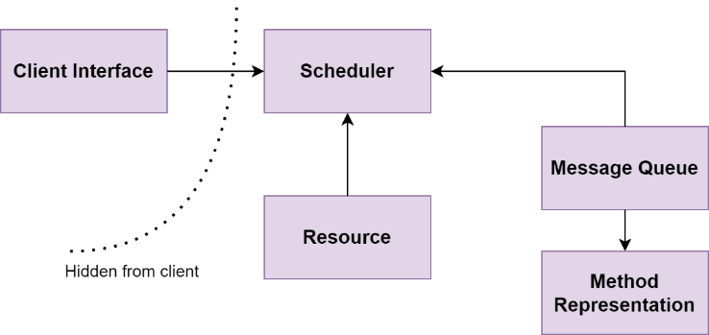

CLASS DIAGRAM
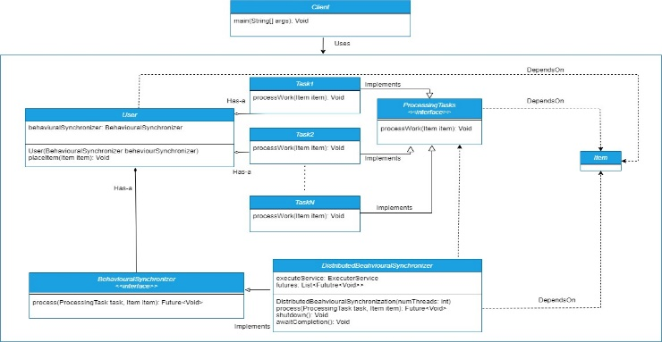

CORE SOLUTION
The provided below code demonstrates the Behavioural Synchronization design pattern, which decouples method execution from method invocation for objects residing in separate threads of control. The BehaviouralSynchronization interface defines the methods accessible for invocation, while the BehaviouralSynchronizationImpl class implements this interface, managing an internal queue (requestQueue) to store requests. Upon instantiation, a background thread is initiated to execute requests asynchronously. The asyncOperation() method enqueues requests, and the executeRequests() method continually processes and executes these requests in the background thread. Finally, the Main class showcases the usage of this pattern by creating an instance of BehaviouralSynchronizationImpl and invoking the asyncOperation() method multiple times, highlighting the separation of method invocation and execution.

SAMPLE CODE
// BehaviouralSynchronization interface defines the methods that can be invoked on the active object
interface BehaviouralSynchronization {
// Method to perform some asynchronous operation
void asyncOperation();
}
// BehaviouralSynchronizationImpl is the implementation of the BehaviouralSynchronization interface
class BehaviouralSynchronizationImpl implements BehaviouralSynchronization {
// Internal queue to store requests
private final BlockingQueue<Runnable> requestQueue = new LinkedBlockingQueue<>();
// Constructor to start the background thread
public BehaviouralSynchronizationImpl() {
// Start the background thread
new Thread(this::executeRequests).start();
}
// Method to enqueue requests
public void asyncOperation() {
requestQueue.offer(() -> {
// Perform the asynchronous operation
System.out.println("Performing asynchronous operation...");
});
}
// Method to execute requests from the queue
private void executeRequests() {
while (true) {
try {
// Take the request from the queue and execute it
Runnable request = requestQueue.take();
request.run();
} catch (InterruptedException e) {
// Handle interruption
Thread.currentThread().interrupt();
}
}
}
}
// Main class to demonstrate the usage of BehaviouralSynchronization pattern
public class Main {
public static void main(String[] args) {
// Create an instance of BehaviouralSynchronization
BehaviouralSynchronization behaviouralSync = new BehaviouralSynchronizationImpl();
// Perform asynchronous operations
behaviouralSync.asyncOperation();
behaviouralSync.asyncOperation();
behaviouralSync.asyncOperation();
}
}

CASE STUDIES

Case Study 1: Social Media Content Moderation System
In a social media content moderation system, the challenge lies in efficiently managing concurrent user interactions while ensuring compliance with community guidelines. To address this, the Behavioral Synchronization Pattern is proposed. By implementing this pattern, the system can dynamically manage content moderation tasks, promoting flexibility and scalability. The approach involves developing modular systems where each moderation task is encapsulated within behavioral synchronization modules. These modules dynamically adapt to changing moderation requirements based on real-time user interactions. As a result, the social media platform achieves dynamic content moderation tailored to user interactions, effectively scaling to handle fluctuating demands while maintaining compliance with community guidelines.

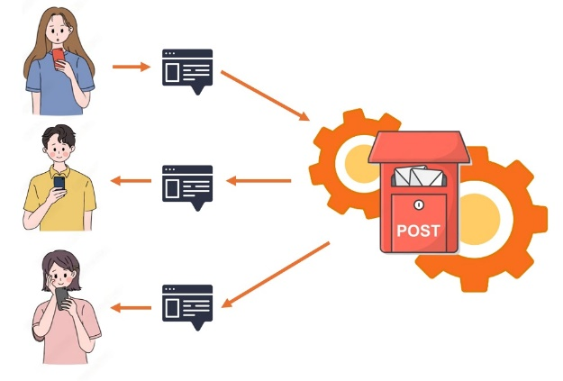

Case Study 2: E-commerce Inventory Management System
In an e-commerce inventory management system, synchronization challenges arise from managing inventory updates from multiple concurrent transactions. To address this, the Behavioral Synchronization Pattern is introduced. This pattern allows for dynamically synchronizing inventory updates while preserving system responsiveness. The implementation approach involves designing behavioral synchronization modules to encapsulate inventory management tasks, enabling dynamic adaptation to transactional demands. These modules adjust synchronization policies based on transaction volume and resource availability. As a result, the e-commerce platform optimizes inventory management processes, ensuring accurate updates while maintaining system responsiveness under varying transaction loads.
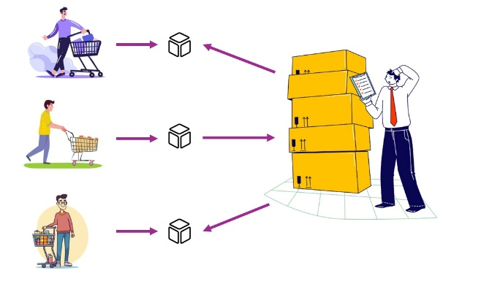

Case Study 3: Real-time Collaborative Document Editing Platform
In a real-time collaborative document editing platform, efficient synchronization mechanisms are needed to handle concurrent edits from multiple users in real-time. To address this challenge, the Behavioral Synchronization Pattern is implemented. This pattern enables dynamic synchronization of document edits while preserving collaborative user experiences. The implementation approach involves developing behavioral synchronization modules to manage concurrent document edits, dynamically adjusting synchronization policies based on user interactions. These modules ensure consistency and responsiveness in real-time collaborative editing. As a result, the document editing platform facilitates seamless collaboration among users, dynamically adapting synchronization strategies to meet real-time editing demands while maintaining data consistency.
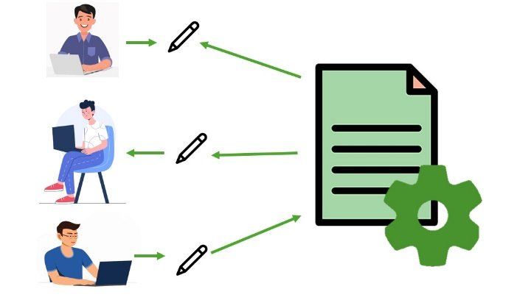

Case Study 4: Distributed Messaging System
In a distributed messaging system, the challenge lies in ensuring timely and accurate delivery of messages across multiple nodes while maintaining system scalability and responsiveness. To address this challenge, the Behavioral Synchronization Pattern can be applied. By implementing this pattern, the messaging system can dynamically synchronize message delivery tasks, promoting flexibility and scalability. The approach involves developing behavioral synchronization modules to encapsulate message delivery tasks, enabling dynamic adaptation to varying network conditions and message priorities. These modules adjust synchronization policies based on message volume, network latency, and node availability. As a result, the messaging system optimizes message delivery processes, ensuring timely and accurate communication while maintaining system responsiveness across distributed environments.
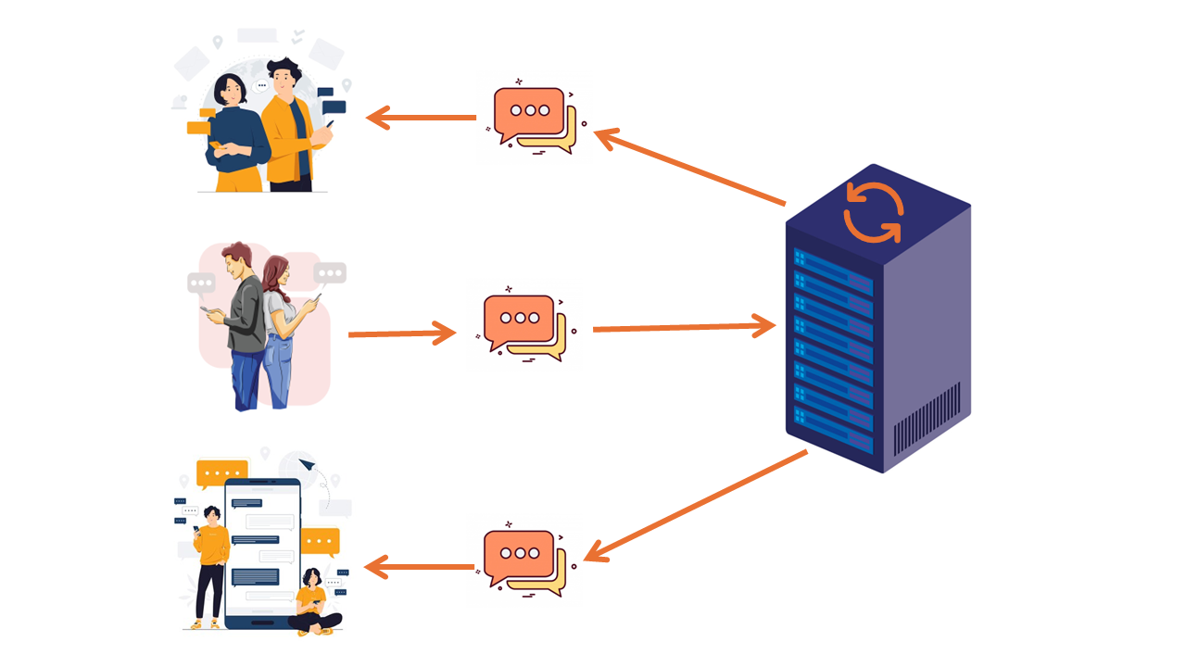

RESULTS
The analysis highlights the superiority of the Behavioural Synchronization Pattern across various aspects compared to the Object Synchronizer, Publish Subscribe, and Pass the Baton patterns. The evaluation encompassed metrics such as synchronization mechanism complexity (measured by the number of classes), modularity, performance, flexibility, and reusability.
The Behavioural Synchronization Pattern emerged as the frontrunner, exhibiting exceptional performance in modularity, flexibility, and reusability. With a remarkable 60% modularity rating and an impressive 85% reusability score, it outperformed other patterns in adaptability and code reusability. Furthermore, its execution time of 20 seconds showcased superior performance efficiency compared to the other patterns.

While each pattern demonstrated strengths in various aspects, the Behavioural Synchronization Pattern's versatility and efficiency make it a compelling choice for developers seeking robust synchronization solutions. Its ability to seamlessly integrate synchronization logic with core functionality while maintaining high modularity and flexibility positions it as a promising option for a wide range of concurrent software applications.

GRAPHICAL ANALYSIS
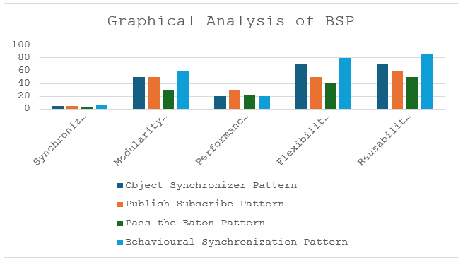

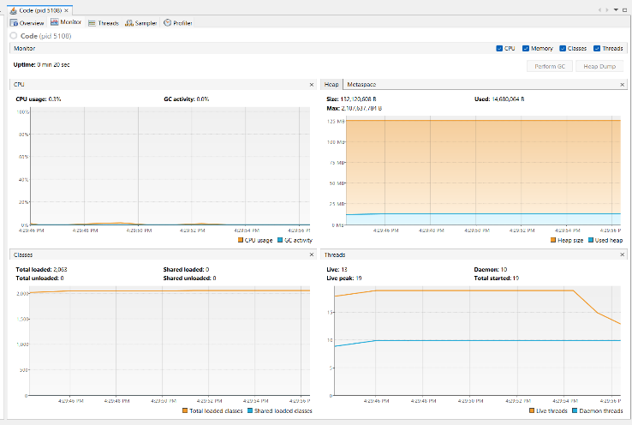


CONCLUSION
In conclusion, the research paper has delved into the deficiencies of conventional object synchronization methodologies such as “Object Synchronizer Pattern”, “Publish Subscribe Pattern”, and “Pass the Baton Pattern” within concurrent systems, highlighting their adverse effects on code structure, modularity, and scalability. Through thorough exploration and analysis, it has been demonstrated that traditional approaches often lead to code tangling, hindering maintainability and scalability in modern software applications.
To address these challenges, the proposed "Behavioral Synchronization Pattern" offers a promising alternative. By decoupling synchronization from functionality and promoting modularity, the pattern enhances code reusability and adaptability in concurrent systems. Through case studies in various domains such as social media content moderation, e-commerce inventory management, and real-time collaborative document editing, the practical effectiveness of the Behavioral Synchronization Pattern has been showcased.
Furthermore, the research paper has emphasized the importance of dynamic synchronization strategies in handling evolving system requirements and fluctuating workloads. By leveraging behavioral synchronization modules and adaptive synchronization policies, systems can achieve scalability, responsiveness, and compliance with community standards. [5]
Overall, the findings of this research contribute significantly to advancing the comprehension and implementation of efficient synchronization techniques tailored for concurrent applications. By embracing innovative solutions such as the Behavioral Synchronization Pattern, software developers can overcome the limitations of traditional synchronization methodologies, paving the way for more resilient, adaptable, and scalable concurrent systems in the modern software landscape.

RECOMMENDATIONS
The research findings underscore several critical recommendations aimed at enhancing synchronization techniques in concurrent systems.
Foremost among these recommendations is the adoption of the Behavioral Synchronization Pattern. This pattern emphasizes decoupling synchronization mechanisms from core functionality, thereby promoting modularity within system designs. By separating concerns related to synchronization, developers can enhance code reusability and adaptability, facilitating the evolution of concurrent systems over time.
Furthermore, there exists considerable potential in the exploration of aspect-oriented programming (AOP) techniques, particularly concerning synchronization. Patterns such as the Publish Subscribe model offer promising avenues for disentangling synchronization concerns from core application logic, thus fostering modularity within complex systems.
Moreover, the integration of dynamic synchronization strategies emerges as a crucial consideration. Systems should leverage behavioral synchronization modules to adapt synchronization policies dynamically based on real-time conditions. This approach ensures optimal performance and responsiveness, enabling systems to effectively handle varying workloads and environmental factors.
Additionally, fostering a culture of continuous performance evaluation is essential for organizations. Regular benchmarking of synchronization techniques against industry standards enables identification of areas for improvement and optimization of system efficiency. This ongoing evaluation ensures that systems remain resilient and adaptive to evolving demands and technological advancements.
Lastly, promoting collaboration and knowledge sharing within the software development community is vital for driving innovation in synchronization techniques. By sharing experiences, case studies, and best practices, practitioners can collectively contribute to the advancement of concurrent programming methodologies. Investment in education and training programs focused on concurrent programming and synchronization techniques is imperative to equip developers with the necessary skills and knowledge, enabling them to design, implement, and optimize concurrent systems effectively.
By embracing these recommendations, software practitioners can navigate the complexities of concurrent programming more effectively, ultimately leading to the development of more resilient, scalable, and responsive software systems.

References

[1] | J. P. J. A. M. Ant´onio Rito Silva, "Object Synchronizer," A Design Pattern for Object Synchronization, p. 10, July 1996.
[2] | D. C. A. d. C. a. M. L. D. Caromel, "ProActive: an Integrated platform for programming and running applications on Grids and P2P systems," 2006.
[3] | M. F. Tennyson, "Publish Subscribe," A Study of the Data Synchronization Concern in the Observer Design Pattern , p. 5, 2010.
[4] | H. L. a. B. P. S. D. Caromel, "Asynchronous and Deterministic Objects," 2004.
[5] | P. Kenneth A. Reek, "Design patterns for semaphores," p. 30, March 2004.
[6] | H. S. a. J. Larus, "Software and the Concurrency Revolution".
[7] | E. A. Lee, "The Problem with Threads".
[8] | H. Sutter, "The Trouble with Locks".
[9] | H. Sutter, "The Free Lunch Is Over: A Fundamental Turn Toward Concurrency in Software".
[10] | H. Sutter, "Use Threads Correctly = Isolation + Asynchronous Messages".
[11] | R. G. L. a. D. C. Schmidt, "Active Object: an Object Behavioral Pattern for Concurrent Programming," September 1995.
[12] | H. Sutter, "Prefer Using Active Objects Instead Of Naked Threads".
[13] |  | "Strona główna systemu ProActive".
[14] |  | R. H. R. J. a. J. V. E. Gamma, "Design Patterns: Elements of Reusable Object-Oriented Software," 1994.
[15] |  | D. C. a. L. Henrio, "A Theory of Distributed Objects," 2005.

